

2017 Polio Health and Wellness Retreat
Body / Mind / Spirit
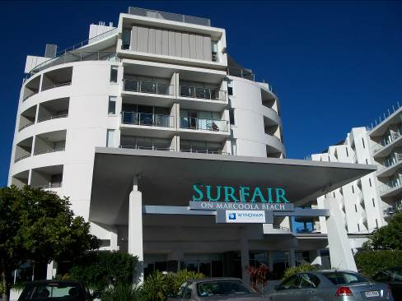
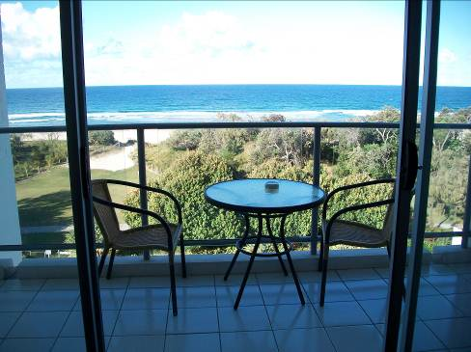
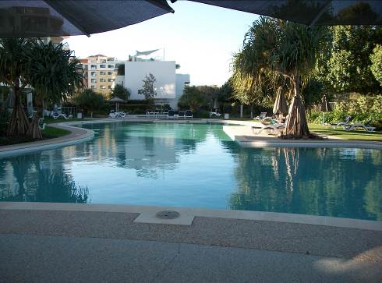

SurfAir Conference & Events Centre Marcoola
923 David Low Way Marcoola Beach QLD 4564

Program
Thursday 26, Friday 27, Saturday 28 and Sunday 29 October 2017

To be completed and returned with Registration Form
(please keep a copy for your records)

Overview
Since it began in 2010, Polio Australia has run its highly successful Polio Health and Wellness Retreats in New South Wales (2010 & 2014), Victoria (2011 & 2015), Queensland (2012), and South Australia (2013). These were all based on a Polio Retreat held by Post-Polio Health International in Warm Springs, Georgia, USA (2009), which was attended by five Australians – four being polio survivors.

The Warm Springs Retreat focused on ‘Body, Mind, Spirit’ and this theme has also proven to be a very effective framework for our Australian Retreats, as it takes a holistic approach towards Chronic Condition Self-Management for polio survivors, their families and carers.

Polio Australia’s Health and Wellness Retreat ‘open circle’ Question and Answer format is a valuable self-management tool – especially the sharing of experience by the participants. The forums fully engage all participants in free-flowing discussion and information exchange, resulting in a clearer understanding and better retention of the management strategies being presented. A survey conducted in 2014 demonstrated that participating in Polio Australia’s Health and Wellness Retreats have enabled participants to improve their ‘health literacy’ and change health behaviour and practice.

The knowledge gained during these Retreats has not only assisted participants to better manage their own condition, but is also being shared with their health professionals, thereby facilitating improved care for other patients presenting with the Late Effects of Polio.

This seventh Retreat back at SurfAir on the Sunshine Coast in Queensland carries on the tradition of being located in a stunning setting which is comfortable and conducive to both relaxing and being open to new information and experiences. It promises to build on previous sessions and participant feedback to present a range of self-management techniques, which will enable participants to achieve general wellbeing, as well as providing options for people to remain as mobile and independent as possible.
Program Preferences
Day 1 – Orientation – Thursday 26 October 2017

Time | Activity | Facilitator
2.00 to 6.00 pm | Registration, room allocation and facility orientation
6.30 to 7.30 pm | Dinner
7.30 pm | Welcome | Dr John Tierney  President, Polio Australia  and  Gillian Thomas  Vice President, Polio Australia
7.40 pm | Guest Speaker: Paul Constable-Calcott  Sunshine Coast Aboriginal man Paul Constable-Calcott has worked most of his life changing the lives of people living with disabilities. Paul contracted polio when he was 18 months old. The disease left him reliant on a cane for walking. It also changed his life for the better, inspiring him to help others. After graduating high school in the 1970s, Paul got a job in disability services. Initially he worked with non-Indigenous people but for the last 10 years he has been able to provide disability services to his “own mob”. | Introduction by Maryann Liethof  National Program Manager,  Polio Australia
8.10 pm | Program Overview and  Brief Announcements | Maryann Liethof
8.30 pm | Participant Introductions | Maryann Liethof
9.00 pm | Relax and Mingle

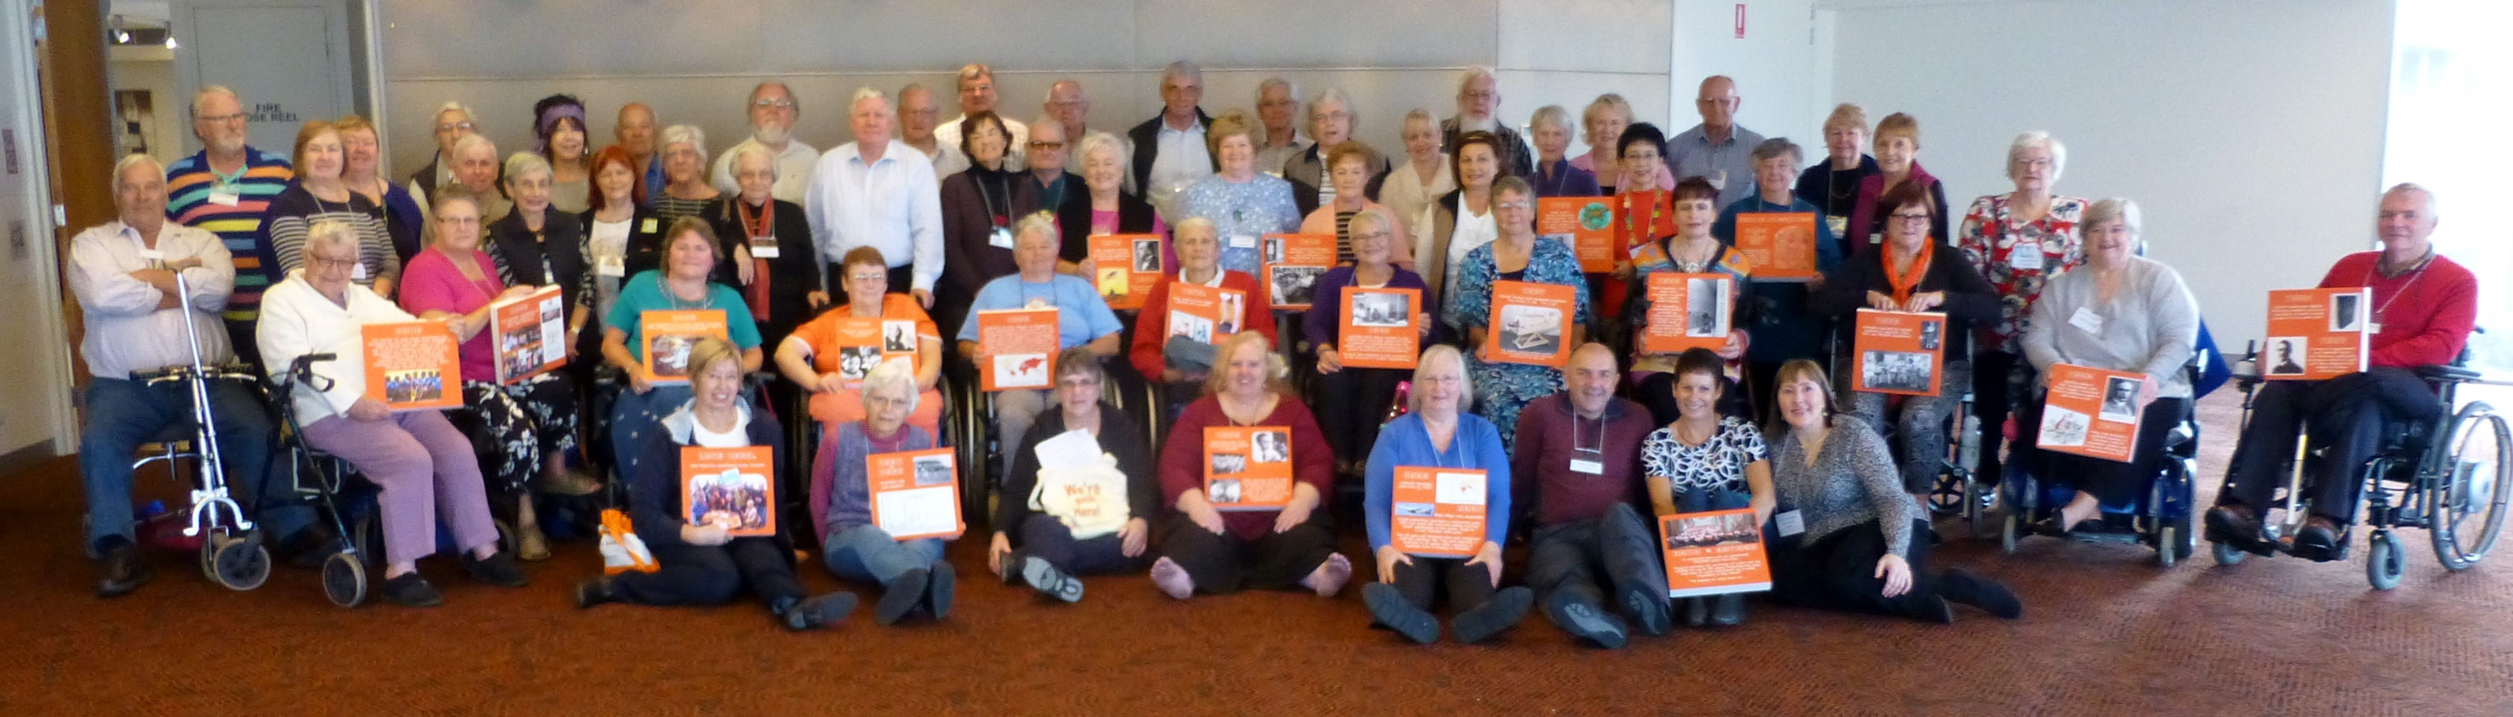

Participants at the Victorian Health and Wellness Retreat, April/May 2015

INSTRUCTIONS FOR COMPLETING THIS FORM
Please read carefully

- This Program lists up to four sessions running concurrently from 10.30am-12.00pm, then 2.00-3.30pm, and 4.00-5.30pm on most days. Please select which sessions you most wish to attend, in order of preference, by ranking every session with a circle, or by highlighting the 1 / 2 / 3 / 4 in the ‘Preferences’ column.
- This ranking needs to be completed by both Participant 1 (polio survivor) and, if relevant, Participant 2 (accompanying spouse/family member/carer).
- Once all the Registration documents have been received and collated, if your first preferred session is full (maximum of 20 people per session), we may need to allocate you to your second preference.
- Where you have not indicated preferences, sessions will be allocated for you. Of course, you are not required to attend any sessions you don’t want to. ‘Personal time’ is always an option!
- Check the “Booked Sessions” on Pages 12 and 13 to select one-to-one clinical consultations (where possible), as well as information on how to book for Soul Ocean Spa Massage and Treatments.
- Make a copy for your records.

Day 2 – The Healthy Body – Friday 27 October 2017

Time | Activity | Facilitator | Preferences
7.30 to 9.00 am | Breakfast
9.15 to 10.00 am | Plenary: Polio Body | Dr Neala Milburn  Rehabilitation Physician  Nambour Selangor Hospital and Noosa Private Hospital and Sunshine Coast University Hospital | Preference N/A
10.00 to 10.25 am | Morning Tea
10.30 am to  12.00 pm | ‘Hold On’ Continence Advice  During the acute polio attack 20% of polio patients experienced voiding symptoms. Theoretically, these problems may return with the decline of function experienced by polio survivors in later years. This will be an important session for many.  – interactive Q & A session | Peter Lysaught  Registered Nurse  Spinal Life Australia | Participant 1  Pref  1  2  3  4 | Participant 2  Pref  1  2  3  4
10.30 am to  12.00 pm | A Healthy Happy Shoulder  Our shoulders are the most complex and mobile region of the body, with 1000s of different degrees of motion and 22 muscles to provide direct shoulder support. A strong, mobile, and healthy shoulder is important to maintain a functional arm. This talk will explore the basis for improving shoulder function by reducing pain, increasing range of motion, and boosting your strength.  – interactive Q & A session | Anthony Nakhle  Practice Physiotherapist  Spinal Life Australia | Participant 1  Pref  1  2  3  4 | Participant 2  Pref  1  2  3  4
10.30 am to  12.00 pm | Vehicle Modifications To Keep You Travelling  This will be a presentation about passenger and driver modifications as well as how to transport your mobility equipment to keep you independent, safe and on the road.  – interactive Q & A session | Patricia Pacheco  Driver Trained Occupational Therapist  Allied Health Service  Spinal Life Australia | Participant 1  Pref  1  2  3  4 | Participant 2  Pref  1  2  3  4
10.30 am to  12.00 pm | Keeping Yourself Mobile  This session is about selecting the right equipment to keep you mobile. It covers the correct use of walkers and walking sticks, and scooter options.  It will also cover some falls prevention techniques and discuss funding options for aged care clients.  – interactive Q & A session | Gail Pitt  Physiotherapist  Allied Health Service  Spinal Life Australia | Participant 1  Pref  1  2  3  4 | Participant 2  Pref  1  2  3  4
10.30 am to  12.00 pm | Respiratory Health Consultation  – booked 20 minute one-to-one session including Spirometer test (free) | Kate Taylor  Respiratory Physiotherapist  Noosa Private Hospital | Booking required  (see page 12)
10.30 am to  12.00 pm | Dysphagia (Swallowing) and Dysphonia (Voice Changes) Consultation  – booked 20 minute one-to-one session (free) | Pippa Chalke  Speech Pathologist  Noosa Private Hospital | Booking required  (see page 12)
12.15 pm | Lunch
12.15 to 2.00 pm | 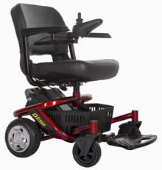  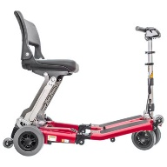  Mobility Equipment Display  Scooters Australia Chermside
12.15 to 2.00 pm |   Information Stand  Spinal Life Australia
12.15 to 2.00 pm |   Information Stand    Ramsay Health Care
1.00 to 2.00 pm | Rest & Relaxation
1.00 to 2.00 pm | Guided Meditation  – 20 min session at 1.30pm |  | Optional
1.00 to 2.00 pm | Nurse Consultation: continence, skin, and wound care management  – booked 20 minute one-to-one session (free) | Peter Lysaught  Registered Nurse  Spinal Life Australia | Booking required  (see page 13)
1.00 to 2.00 pm | Physiotherapy Consultation  – booked 20 minute one-to-one session (free) | Anthony Nakhle  Physiotherapist  Spinal Life Australia | Booking required  (see page 12)
1.00 to 2.00 pm | OT / Vehicle Mods Consultation  – booked 20 minute one-to-one session (free) | Patricia Pacheco  Occupational Therapist  Spinal Life Australia | Booking required  (see page 12)
1.00 to 2.00 pm | Mobility Consultation  – booked 20 minute one-to-one session (free) | Gail Pitt  Physiotherapist  Spinal Life Australia | Booking required  (see page 13)
 | Respiratory Health Consultation  – booked 20 minute one-to-one session including Spirometer test (free) | Kate Taylor  Respiratory Physiotherapist  Noosa Private Hospital | Booking required  (see page 12)
 | Dysphagia (Swallowing) and Dysphonia (Voice Changes) Consultation  – booked 20 minute one-to-one session (free) | Pippa Chalke  Speech Pathologist  Noosa Private Hospital | Booking required  (see page 12)
2.00 to 3.30 pm | A Healthy Happy Shoulder  Our shoulders are the most complex and mobile region of the body, with 1000s of different degrees of motion and 22 muscles to provide direct shoulder support. A strong, mobile, and healthy shoulder is important to maintain a functional arm. This talk will explore the basis for improving shoulder function by reducing pain, increase range of motion, and boosting your strength.  – interactive Q & A session (Repeat) | Anthony Nakhle  Practice Physiotherapist  Spinal Life Australia | Participant 1  Pref  1  2  3  4 | Participant 2  Pref  1  2  3  4
2.00 to 3.30 pm | Vehicle Modifications To Keep You Travelling  This will be a presentation about passenger and driver modifications as well as how to transport your mobility equipment to keep you independent, safe and on the road.  – interactive Q & A session (Repeat) | Patricia Pacheco  Occupational Therapist  Spinal Life Australia | Participant 1  Pref  1  2  3  4 | Participant 2  Pref  1  2  3  4
2.00 to 3.30 pm | To Brace Or Not To Brace  This is an important question for anyone who is tripping more often, or is noticing progressive muscle weakness. Don’t wait until you break a bone!  – interactive Q & A session | Clint Nielsen  Orthotist/Director  Orthotic Solutions Qld | Participant 1  Pref  1  2  3  4 | Participant 2  Pref  1  2  3  4
2.00 to 3.30 pm | Healthy Eating For The Not-So-Active  This workshop will discuss ideas for reducing energy intake whilst still maintaining flavours. Includes a demonstration of a healthy nutritious food option, with printed copies of the recipe for all participants.  – interactive Q & A session | Jody Pollard  Dietitian  Total Nutrition Dietitian | Participant 1  Pref  1  2  3  4 | Participant 2  Pref  1  2  3  4
2.00 to 3.30 pm | Partnering Polio  This is a guided discussion for anyone who has come along to the Retreat with a person who is post-polio. | Graeme Smith  Husband of Polio Survivor | Please tick here if Partner/Family/Friend attending   (see page 11)
2.00 to 3.30 pm | Nurse Consultation: continence, skin, and wound care management  – booked 20 minute one-to-one session (free) | Peter Lysaught  Registered Nurse  Spinal Life Australia | Booking required  (see page 13)
2.00 to 3.30 pm | Mobility Consultation  – booked 20 minute one-to-one session (free) | Gail Pitt  Physiotherapist  Spinal Life Australia | Booking required  (see page 13)
2.00 to 3.30 pm | Orthotics Assessment  – booked 25 minute one-to-one session (free) | Clint Nielsen  Orthotist  Orthotic Solutions Qld | Booking required  (see page 13)
 | Respiratory Health Consultation  – booked 20 minute one-to-one session including Spirometer test (free) | Kate Taylor  Respiratory Physiotherapist  Noosa Private Hospital | Booking required  (see page 12)
 | Dysphagia (Swallowing) and Dysphonia (Voice Changes) Consultation  – booked 20 minute one-to-one session (free) | Pippa Chalke  Speech Pathologist  Noosa Private Hospital | Booking required  (see page 12)
3.30 to 3.55 pm | Afternoon Tea |  | Preference N/A
4.00 to 5.30 pm | New Insights, Innovation And Information In Treating Common Foot Problems  Today’s podiatrists use a range of new technology to diagnose, treat and repair feet that no longer perform as they should. Looking toward to the future in foot health, be assured that podiatrists can offer a solution to many common foot problems. Preventative and active treatments are many and varied. Learn how podiatry can improve your mobility and reduce foot pain. I also have a passion for diabetes, so if you are diabetic this foot session is a must!  – interactive Q & A session | Maria Zauner  Podiatrist / Founder  Sun Coast Podiatry | Participant 1  Pref  1  2  3  4 | Participant 2  Pref  1  2  3  4
4.00 to 5.30 pm | Optimising Nutrition And Anti-Inflammatory Foods  Did you know that that certain foods can exacerbate inflammation, and others that can reduce it? Find out how changing what you eat can help to manage your inflammation levels. Includes a demonstration of a healthy nutritious food option, with printed copies of the recipe for all participants.  – interactive Q & A session | Jody Pollard  Dietitian  Total Nutrition Dietitian | Participant 1  Pref  1  2  3  4 | Participant 2  Pref  1  2  3  4
4.00 to 5.30 pm | Medicines: All you've ever wanted to know but never asked  A joint exploration of the world of medicines. The good, the bad, and maybe the ugly. What we explore is in your hands in this interactive question and answer session. What should I be taking? How do I know if it's working? When can I stop taking something? Can this go with that? What we talk about is only limited by your imagination!  – interactive Q & A session | John Woodward  Pharmacist  Pharmacist For You | Participant 1  Pref  1  2  3  4 | Participant 2  Pref  1  2  3  4
4.00 to 5.30 pm | Negotiating My Aged Care  Attend this session to learn about the types of services and funding available to people aged 65 plus, which will enable you to stay living in your own home and local community.  – interactive Q & A session | Rhee Duthie  Client Services Manager  Queensland and New South Wales  Care Connect | Participant 1  Pref  1  2  3  4 | Participant 2  Pref  1  2  3  4
6.30 to 7.30 pm | Dinner
7.30 pm onwards | Free time / Movie: The Immortal Life of Henrietta Lacks (1 hour 33 mins)    Henrietta Lacks was an African American woman whose cancer cells were the source of the HeLa cell line, the first immortalized cell line and one of the most important cell lines in medical research. An immortalized cell line will reproduce indefinitely under specific conditions, and the HeLa cell line continues to be a source of invaluable medical data to the present day. Lacks was the unwitting source of these cells from a tumor biopsied during treatment for cervical cancer in 1951.  The ability to rapidly reproduce HeLa cells in a laboratory setting has led to many important breakthroughs in biomedical research, and by 1954, Jonas Salk was using HeLa cells in his research to develop the polio vaccine.  As was then the practice, no consent was obtained to culture her cells, nor was she or her family compensated for their use. “The Immortal Life of Henrietta Lacks” is much more than a portrait of the Lacks family. It is also a critique of science that insists on ignoring the messy human provenance of its materials.

Day 3 – The Healthy Mind – Saturday 28 October 2017

Time | Activity |  | Facilitator | Preferences
7.30 to 9.00 am | Breakfast
9.15 to 10.00 am | Plenary: Investigating the Healthy Mind |  | Corey Jackson  Psychologist/Trainer  Equipoise Training | Preference N/A
10.00 to 10.25 am | Morning Tea
10.30 am to 12.00 pm | Cultivating Emotional Balance  Much of our experience of the world comes to us through our emotions. Almost everyone experiences emotional reactions which are a little out of proportion to what triggers them and these can sometimes cause us difficulties.  Cultivating Emotional Balance is a program that combines ancient traditional and modern researched-based techniques and understanding to give us choice in how we react in emotional situations. More specifically, it provides tools for us to identify and increase constructive emotional habits while reducing destructive ones. With a little training, we can very quickly identify when we are in the grip of an emotion and choose to act in a way that will lead to better wellbeing and relationships.  – interactive Q & A session |  | Corey Jackson  Psychologist/Trainer  Equipoise Training | Participant 1  Pref  1  2  3  4 | Participant 2  Pref  1  2  3  4
10.30 am to 12.00 pm | But What About Me?  – Exploring self-care strategies for well being and quality of life  One of the important factors identified by people who are experiencing the late effects of polio and other chronic illnesses is the need to care for oneself. However, despite this, self-care is often at the bottom of the list in terms of managing our condition.  In this session, participants will get to explore what works for them: what are the barriers that prevent them from caring for themselves, engage in some hands on activities, and take home a plan of action for making self-care the Number 1 priority in their lives.  – interactive Q & A session |  | Dr Pat Dorsett  and  Dr Sandra Woodbridge  Senior Lecturers  School of Human Services and Social Work  Griffith University | Participant 1  Pref  1  2  3  4 | Participant 2  Pref  1  2  3  4
10.30 am to 12.00 pm | Planning Ahead: Let’s Talk  Nobody can predict the future. Planning ahead can bring peace of mind to you, your family and your friends. It can ensure that your financial, health and personal wishes are respected and followed if you are unable to act yourself.  – interactive Q & A session |  | Fran Kay  Peer Educator  COTA Qld | Participant 1  Pref  1  2  3  4 | Participant 2  Pref  1  2  3  4
10.30 am to 12.00 pm | Chair Yoga  This session offers the benefits of Yoga stretching and strengthening exercises using Yoga breathing and relaxation techniques.  – practical session / seated |  | Myra Timmerman  Yoga Teacher  U3A Sunshine Coast | Participant 1  Pref  1  2  3  4 | Participant 2  Pref  1  2  3  4
12.15 pm | Lunch
1.00 to 2.00 pm | Rest & Relaxation
1.00 to 2.00 pm | Guided Meditation  – 20 min session at 1.30pm |  |  | Optional
2.00 to 3.30 pm | Cryptic Crosswords  Cryptic crosswords can seem dauntingly nonsensical at first glance, but the fundamental principles of cryptic clueing are actually quite simple. Practice your mental gymnastics in this fun and interactive session.  – practical session | Gillian Thomas  Vice President  Polio Australia |  | Participant 1  Pref  1  2  3  4 | Participant 2  Pref  1  2  3  4
2.00 to 3.30 pm | Feldenkrais: Learn to move mindfully, with greater ease and pleasure  The Feldenkrais Method® is a different body learning method. It uses gentle movement explorations along with directed awareness of how you are moving. Become more aware of your whole self – what your current movement habits are.  – practical session / seated | Robyn Lavery  Movement Teacher  Robyn Lavery Feldenkrais |  | Participant 1  Pref  1  2  3  4 | Participant 2  Pref  1  2  3  4
2.00 to 3.30 pm | Canasta  Would you like to learn to play Canasta? This session will explain the objective of the game, how to play, playing as teams, and the other basics of this fast-paced card game.  – practical session | Mal Stewart  Canasta Group  U3A Sunshine Coast |  | Participant 1  Pref  1  2  3  4 | Participant 2  Pref  1  2  3  4
2.00 to 3.30 pm | Write Your Story  This session will help you to start your autobiographical project and make it interesting for your readers.  – interactive Q & A session | Jenny Riley  Tutor  U3A Sunshine Coast |  | Participant 1  Pref  1  2  3  4 | Participant 2  Pref  1  2  3  4
2.00 to 3.30 pm | Partnering Polio  This is a guided discussion for anyone who has come along to the Retreat with a person who is post-polio. | Graeme Smith  Husband of Polio Survivor |  | Please tick here if Partner/Family/Friend attending   (see page 11)
3.30 to 3.55 pm | Afternoon Tea
4.00 to 5.30 pm | Miniature Gardens  Come along and create all the elements of a garden in a miniature, complete with container, soil, pebbles, plants and decorative features.  – practical session / take home project  Max. 12 participants | Rachael Edwards  Art Teacher  Bright Brains Happy Hearts |  | Participant 1  Pref  1  2  3  4 | Participant 2  Pref  1  2  3  4
4.00 to 5.30 pm | Kitchen Table Economics & Investing  If you want to know how professionals actually invest, if you want to make sense of the finance news, if you are concerned about the economic legacy this generation is leaving your children, then you must attend this interactive session. | Damian Lillicrap  Bare Naked Economist  (Head of Investment Strategy, QSuper)  and  Graeme Mackenzie  Retired CPA |  | Participant 1  Pref  1  2  3  4 | Participant 2  Pref  1  2  3  4
4.00 to 5.30 pm | Live Love Life Colourfully  Skincare, makeup, and fashion styling for all ages. This workshop will provide you with tips and techniques to help you look your best and to feel amazing!  – interactive session | Sarah Hutson  Creative Owner  SFH Designs  and  Sue Mackenzie  Board Member  Polio Australia |  | Participant 1  Pref  1  2  3  4 | Participant 2  Pref  1  2  3  4
6.30 to 7.30 pm | Dinner
Between  8.00 and 9.30 pm   | “Polio’s Got Talent” Show      Have you got a talent you’d like to share with a captive audience? Singing a song? Playing a musical instrument? Reading poetry? Doing a magic trick? Telling jokes? You can even get a group of friends together to share the act. Whatever it is, let your star talent shine tonight!   |  |  | Please tick below if you would like to be in the talent show and tell us what your act is.    My Act:

Day 4 – The Healthy Spirit – Sunday 29 October 2017

Time | Activity |  | Facilitator | Preferences
7.30 to 9.00 am | Breakfast
9.15 to 10.00 am | Plenary: Spirit |  | Joanna Teazis  Coordinator  Sunshine Coast Lodge  The Theosophical Society | Preference N/A
10.00 to 10.25 am | Morning Tea
10.30 am to  12.00 pm | Philosophy, Science and World Religions  This session is intended to encourage open-minded enquiry into understanding ourselves and our place in the universe.  – interactive group discussion |  | Joanna Teazis  Coordinator  Sunshine Coast Lodge  The Theosophical Society | Participant 1  Pref  1  2  3  4 | Participant 2  Pref  1  2  3  4
10.30 am to  12.00 pm | Introduction to Buddhism  Did you know that Buddhism, in its natural form, is not a religion; rather it is a tradition that focuses on personal spiritual development. Buddhists strive for a deep insight into the true nature of life and do not worship gods or deities. Learn more during this brief but fascinating overview.  – interactive Q & A session |  | Venerable Tony Beaumont  Chenrezig Institute | Participant 1  Pref  1  2  3  4 | Participant 2  Pref  1  2  3  4
10.30 am to  12.00 pm | Finding God in Christianity  What was your introduction to God? Has He always been part of your family’s life? Did you have an epiphany? What does believing in God mean to you? Or are you still on your own quest for faith? These questions will form the basis of an open discussion for those who value a more traditional version of spiritualism.  – interactive group discussion | Jill Pickering  Volunteer  Polio Australia |  | Participant 1  Pref  1  2  3  4 | Participant 2  Pref  1  2  3  4
12.15 pm | Lunch
1.15 to 2.30 pm | Closing Plenary | Polio Australia Executive |  | Preference N/A

Partnering Polio

Friday:  2.00 to 3.30 pm Name:

Saturday:  2.00 to 3.30 pm Name:
Booked Sessions

As with all of Polio Australia’s Health and Wellness Retreats, we encourage participants to take advantage of free one-to-one clinical consultations and paid spa options available throughout the Retreat. Of course, it is unavoidable that some of these appointments will clash with the sessions. However, all the presenters are made aware that people may be coming and going according to these additional bookings.

NOTE: Due to limited appointment times, not everyone will be able to be accommodated. A list of successful ‘Booked Consultations’ and those on the ‘waiting list’ will be provided at the Retreat.

Friday 27th October 2017

Respiratory Consultation – 20 min with Kate Taylor

❑ 10.30 to 10.50 am Participant:  One  Two
❑ 10.50 to 11.10 am Participant:  One  Two
❑ 11.10 to 11.30 am Participant:  One  Two
❑ 11.30 to 11.50 am Participant:  One  Two
❑ 11.50 to 12.10 pm Participant:  One  Two
Lunch Break
❑ 1.00 to 1.20 pm Participant:  One  Two
❑ 1.20 to 1.40 pm Participant:  One  Two
❑ 1.40 to 2.00 pm Participant:  One  Two
❑ 2.00 to 2.20 pm Participant:  One  Two
❑ 2.20 to 2.40 pm Participant:  One  Two
❑ 2.40 to 3.00 pm Participant:  One  Two

Dysphagia/Dysphonia Consultation – 20 min with Pippa Chalke

❑ 10.30 to 10.50 am Participant:  One  Two
❑ 10.50 to 11.10 am Participant:  One  Two
❑ 11.10 to 11.30 am Participant:  One  Two
❑ 11.30 to 11.50 am Participant:  One  Two
❑ 11.50 to 12.10 pm Participant:  One  Two
Lunch Break
❑ 1.00 to 1.20 pm Participant:  One  Two
❑ 1.20 to 1.40 pm Participant:  One  Two
❑ 1.40 to 2.00 pm Participant:  One  Two
❑ 2.00 to 2.20 pm Participant:  One  Two
❑ 2.20 to 2.40 pm Participant:  One  Two
❑ 2.40 to 3.00 pm Participant:  One  Two

Physiotherapy Consultation – 20 min with Anthony Nakhle

❑ 12.50 to 1.10 pm Participant:  One  Two
❑ 1.10 to 1.30 pm Participant:  One  Two
❑ 1.30 to 1.50 pm Participant:  One  Two

Occupational Therapy / Vehicle Modifications Consultation – 20 min with Patricia Pacheco

❑ 12.50 to 1.10 pm Participant:  One  Two
❑ 1.10 to 1.30 pm Participant:  One  Two
❑ 1.30 to 1.50 pm Participant:  One  Two

Nurse Consultation: Continence, Skin and Wound Care – 20 min with Peter Lysaught

❑ 1.00 to 1.20 pm Participant:  One  Two
❑ 1.20 to 1.40 pm Participant:  One  Two
❑ 1.40 to 2.00 pm Participant:  One  Two
❑ 2.00 to 2.20 pm Participant:  One  Two
❑ 2.20 to 2.40 pm Participant:  One  Two
❑ 2.40 to 3.00 pm Participant:  One  Two
❑ 3.00 to 3.20 pm Participant:  One  Two

Mobility Consultation – 20 min with Gail Pitt

❑ 1.00 to 1.20 pm Participant:  One  Two
❑ 1.20 to 1.40 pm Participant:  One  Two
❑ 1.40 to 2.00 pm Participant:  One  Two
❑ 2.00 to 2.20 pm Participant:  One  Two
❑ 2.20 to 2.40 pm Participant:  One  Two
❑ 2.40 to 3.00 pm Participant:  One  Two
❑ 3.00 to 3.20 pm Participant:  One  Two

Orthotic Assessment – 25 min with Clint Nielsen

❑ 2.00 to 2.25 pm Participant:  One  Two
❑ 2.30 to 2.55 pm Participant:  One  Two
❑ 3.00 to 3.25 pm Participant:  One  Two

Soul Ocean Spa Massage & Treatments – Book Directly With Spa


The luxurious Soul Ocean Spa is located onsite and is offering ‘Polio Retreat’ participants 10% off regular prices from their full Treatment Menu as well as a range of specials. Examples include:

- 30 Minute Massage = $54 (regular price $60)
- 60 Minute Massage = $90 (regular price $100)
- 30 Minute Massage plus 30 Minute Facial = $99

Book directly and early to avoid missing this great opportunity to relax and be pampered by Soul Ocean’s friendly and professional staff. Payment is required when booking to ensure you get the time, day and treatment you want.

Contact Rachel at Soul Ocean Spa on Phone: 07 5450 6136 or 0415 709 888

or Email: info@souloceanspa.com.au

